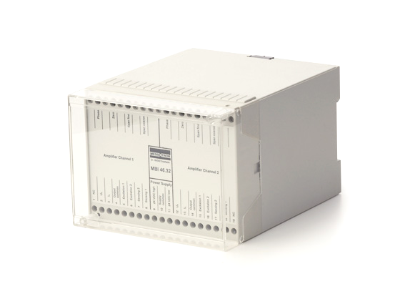

Operating Instructions

CF Measuring Amplifier

Series MBI 46.32

Contents
1 General 4
1.1 Warranty and liability 4
1.2 Technical support and contact details 4
2 Safety Instructions 5
2.1 Intended use 5
2.2 Conditions at the installation site 5
2.3 General hazards if the safety instructions are not followed 5
2.4 Qualified personnel 5
2.5 Check for transport damage 6
3 Warning and Other Messages 6
3.1 Use of warning messages 6
3.2 Other messages 7
4 Product Description 7
4.1 Glossary 7
4.2 Function and design 10
4.3 Suitable displacement sensors 12
4.4 Overview of types and options 15
5 Placing into Service 16
5.1 Pin assignment 16
5.2 Setting options of the measuring amplifier 18
5.3 Adjustment using trimming potentiometer 21
5.4 Basic configuration of measuring amplifier 23
5.5 Optimizing the linearity characteristic of the measuring chain 31
5.6 Improving the noise rejection 34
6 Operation 35
7 Repairs 35
8 Maintenance 36
8.1 Preventative maintenance 36
8.2 Cleaning 36
9 Disposal 36
10 EU Declaration of Conformity 37
11 Technical Specifications 38

General
Read carefully before use!
Please read and always follow these operating instructions.
Retain for future reference!
Please retain these operating instructions in a safe location for future reference.
Treat the identification plate on the device with care!
If the device has to be repaired or replacement parts are needed, you must specify the model and the serial number. Both are indicated on the identification plate.
Warnings and safety instructions
Observe the warnings and safety instructions in these operating instructions to avoid physical injury and property damage.

Warranty and liability
Warranty and liability claims against MESSOTRON cannot be raised if
- damage occurs because the operating instructions are not followed or
- modifications have been made that are not documented in the operating instructions.

Technical support and contact details
Please contact us if you have any questions. You can reach us at the following contact address:
MESSOTRON Hennig GmbH & Co KG
Friedrich-Ebert-Str. 37
64342 Seeheim-Jugenheim, Germany
Phone: +49 (0) 6257 82331
Fax: +49 (0) 6257 85783
Email: info@messotron.de
For further information please visit our webpage: www.messotron.com/service.

Safety Instructions

Intended use
The carrier frequency measuring amplifier MBI 46.32 (“the device”) must only be used to operate inductive displacement sensors of the differential transformer type (LVDTs) and differential inductors / half-bridge sensors (LVITs) as well as the associated signal processing equipment. The device must only be used with passive displacement sensors (i.e. sensors without active embedded electronics). Any other use is considered improper use.
Observe the legal and safety regulations required for the respective application. This also applies to the use of accessories.
In order to ensure proper and safe operation, the device must only be operated according to the information provided in these operating instructions.

Conditions at the installation site
Check the required conditions at the installation site (e.g. temperature and weather conditions). The limits for the device are specified in chapter 11 “Technical Specifications”.
Have the device checked by MESSOTRON before putting it back into service if foreign objects or liquids got inside the device.
Do not use the device near other devices, machines or equipment that generate strong electric or magnetic fields.

General hazards if the safety instructions are not followed
The device is designed to the state of the art and is safe when used as intended. However, if the device is used and operated improperly (e.g. by insufficiently qualified personnel), residual hazards may arise.

Qualified personnel
The device must only be placed into service and operated by trained skilled persons who are aware of the hazards involved. The skilled persons must be familiar with the national occupational health and safety regulations, accident prevention regulations as well as approved technical practices and guidelines.

Check for transport damage
Before unpacking, check the packaging of the device for damage. If the packaging has been damaged during transport and there is reason to believe that the device may be damaged, it must not be placed into service. In this case, have the device checked by MESSOTRON before use.

Warning and Other Messages

Use of warning messages
The following hazard levels according to ANSI Z 535 are used for warning messages:
Warning sign, signal word | Explanation
DANGER | Indicates a hazardous situation, which, if not avoided, will result in death or serious injury.
WARNING | Indicates a hazardous situation, which, if not avoided, could result in death or serious injury.
CAUTION | Indicates a hazardous situation, which, if not avoided, could result in minor or moderate injury.
NOTICE | Indicates a potential property damage: The product could be damaged or the environment could be harmed.

Warning messages affecting your personal safety are very clearly marked. Always observe these warnings to avoid physical injury and property damage.

A warning message (for either Danger, Warning or Caution) looks like this:
WARNING
Cause and potential consequences
- How to avoid the hazard

Other messages
NOTE | Notes contain important information for optimum use of the device. Not observing a note may result in incorrect measurements; however, this will usually not result in damage to the device.

Product Description

Glossary
Term | Definition
Carrier frequency measuring amplifier | Series MBI 46.32 CF measuring amplifiers are used in inductive measuring chains  - to provide the inductive sensor with the required excitation voltage,  - to amplify the sensor output signal and  - to convert the output signal into a normalized analog current or voltage signal.
Types of displacement sensors
Displacement sensor | In these instructions the term “displacement sensor” often abbreviated to “sensor” is used. These de-vices are also known as “transducers” or “position sensors”.  MESSOTRON differentiates the following three displacement sensor types:
Differential transformer (LVDT) | Differential transformers consist of a primary coil and two secondary coils placed around a movable magnetic core. The coils are coupled based on the transformer principle.  The acronym LVDT stands for “Linear Variable Differential Transformer”.
Inductive half-bridge, differential inductor (LVIT) | Differential inductors represent a Wheatstone half-bridge with two measuring coils. The impedance of the two measuring coils is influenced in opposite directions by a movable magnetic core.  They are also referred to as LVIT (Linear Variable Inductance Transducer).
Long-stroke sensors based on the eddy current principle | Long-stroke sensors are inductive displacement sensors using a half-bridge circuit. Only one coil is used for measuring. The second coil is designed as a space-saving equivalent circuit. A movable measuring tube (made of a conductive material) changes the impedance of the measuring coil based on the eddy current principle.
Construction
Symmetric sensor | The measuring coil halves of differential transformers and inductors are built in a symmetrically (mirrored) design. The electrical zero is at the center of the nominal stroke.
Asymmetric sensor | The space-saving equivalent circuit of the 2nd coil of the long-stroke sensors results in an asymmetric design enabling a more favorable displacement-to-length ratio. The electrical zero is at the start of the nominal stroke (when the measuring tube completely covers the measuring coil).
Immersion core (core with core rod) | The immersion core is a two-piece, rod-shaped part consisting of  - a magnetic core and  - a core rod, i. e. a purely mechanical extension made of a non-magnetic material.
Measuring tube | The measuring tube is made of aluminum. In asymmetric displacement sensors it is moved over the measuring coil drawing energy from the coil field proportional to the tube’s position (eddy current effect).
Characteristic data
Excitation voltage (U_{sp}) | AC voltage (typically 1...5 Vpp), supplying the inductive sensor.
Carrier or bridge frequency | Excitation frequency (usually 5 or 10 kHz) to drive the inductive displacement sensor.
Measurement voltage | Output signal proportional to the displacement (AC voltage in the mV range) provided by the inductive displacement sensor.
Zero point | At the electrical zero, the output signal of the displacement sensor is zero. Refer to the data sheet of the displacement sensor for physical position of the zero point.
Rated output | The rated output of the sensor is defined as the ratio of the sensor output voltage (measurement voltage) to the sensor input voltage (excitation voltage) at the end of the nominal stroke. For calibrated displacement sensors the rated output is e.g. 80 mV/V, independent of the nominal stroke of the displacement sensor.  In older displacement sensor data sheets, the term “nominal output” is used.
Sensitivity | The sensitivity is defined as the ratio of the measurement voltage to the excitation voltage per mm of displacement (e.g. 10 mV/V/mm).  For standardization purposes information on sensitivity and rated output for MESSOTRON displacement sensors is determined and provided independent of phase (i.e. without consideration of a phase shift).
Phase (phase shift) | With inductive sensors and/or long connecting cables, there will be a noticeable phase shift between the excitation voltage and the measurement voltage. This phase shift lowers the (effective) sensitivity of the sensor in the measuring chain.  All MESSOTRON series MBI 46.3x measuring amplifiers can compensate a phase shift.
Linearity error | The linearity error of measuring devices is the maximum deviation between the nominal characteristic (straight line) and the real characteristic of the measuring device. The error information is referenced to the total measuring range (FSO / Full Scale Output).

Signal output of the measuring amplifier
(Nominal) output range | The (nominal) output range of the measuring amplifier indicates the range covered by the output signal, if the displacement sensor operates in the (nominal) measuring range.
Current output | Analog current output of the measuring amplifier:  typically 4...20 mA for the nominal stroke
Voltage output | Analog voltage output of the measuring amplifier:  - typically ±10 V for symmetric displacement sensors  - typically 0...10 V for asymmetric displacement sensors

Function and design
The measuring amplifier MBI 46.32 is available as a 1-channel and as a 2-channel version. One displacement sensor can be operated per channel. Using the 2-channel version all functions are available in duplicate. This means, all parameters described in these Operating instructions can be adjusted or set individually and independently for each channel.
In these Operating instructions, the 1-channel version is mainly described as the description for the second channel would be identical.
The MBI 46.32 generates the AC voltage (excitation voltage U_{sp}) required for operating inductive displacement sensors. The frequency (carrier frequency) is typically 5 kHz (optionally 1...20 kHz).
The output signal proportional to the displacement (the measurement voltage) returned by the displacement sensor is preamplified by the measuring amplifier and evaluated ratiometrically, i.e. in relation to the excitation voltage. This way measurement errors are avoided that result from fluctuations of the excitation voltage, e.g. due to an impedance change of the displacement sensor.
In subsequent stages, the measurement signal is filtered and scaled to the desired output range for further processing.

Figure 1 Block diagram with terminal assignment
PE Trimmer potentiometer for gain adjustment
P0 Trimmer potentiometer for zero adjustment
PPh Trimmer potentiometer for phase compensation
R2 Resistor for setting the trim range for the zero point
R6/R7 Resistors for zero offset
RE Resistor for basic configuration of gain
C1/C2 Capacitors for phase compensation
C4 Capacitor for adjustment of the cut-off frequency
J1/J2 Plug contact to switch on the preamplifier in case of low output signal of the displacement sensor; (position J1: with 6x preamplification; position J2: no preamplification)

Suitable displacement sensors
The MBI 46.32 CF measuring amplifier can be used with a variety of inductive sensors. For details on the requirements, refer to the technical specifications in chapter 11.
NOTE | In particular check the following:  - Electrical design (type of displacement sensor),  - Required carrier frequency,  - Excitation voltage and  - Rated output / sensitivity.

The following chapters describe the electrical design of the three displacement sensor types offered by MESSOTRON.

Linear Variable Inductance Transducers (LVITs)
Electrically displacement sensors based on the differential inductor principle, also called LVITs, represent a Wheatstone half-bridge consisting of two measuring coils. If the core moving inside the coils is in its mid-position (electrical zero), both measuring coils will show the same impedance. The bridge circuit is balanced. The measurement voltage is zero.
Figure 2 Measuring amplifier with differential inductor
If the core is moved out of its mid-position, the impedances of the two measuring coils change and the measurement voltage increases proportionally with the displacement within the measuring range.

Linear Variable Differential Transformers (LVDTs)
Differential transformers consist of a primary coil and two secondary coils placed around an immersion core. The coils are coupled based on the transformer principle.
AC voltage drives the primary coil inducing a voltage in the secondary coils. When the immersion core is at its mid-position, this voltage is zero due to the symmetrically wound secondary coils. If the immersion core is moved, the measurement voltage changes proportionally to the displacement of the core.
Figure 3 Measuring amplifier with differential transformer

Long-stroke sensor (eddy current principle)
Long-stroke sensors are displacement sensors using a half-bridge circuit. Only one coil is used as the measuring coil. The second coil is designed as a space-saving equivalent circuit. A movable measuring tube (made of a conductive material) changes the impedance of the measuring coil based on the eddy current principle. In contrast to symmetric displacement sensors, the electrical zero of long-stroke sensors is at the start of the nominal stroke (the measuring tube completely covering the measuring coil).
Figure 4 Measuring amplifier with long-stroke sensor

Overview of types and options
The measuring amplifier is available in the following versions:
MBI 46.32. | x |  | y |  | /zzz
Power supply |  |  |  | Output signal | Options
±15 VDC | 1 |  | 1 | ±10 V output | /nn kHz  Alternative carrier frequency in the range (1...20 kHz)
+24 VDC | 3 |  | 2 | 4 ... 20 mA output | /0-10 V ¹⁾  Output signal 0...10 V
2-channel  +24 VDC | 4 |  |  |  | /0 - 20mA  Output signal 0...20 mA
/GP
“Course pot” for rough adjustment of gain

- Option for symmetric displacement sensors (instead of ±10 V)
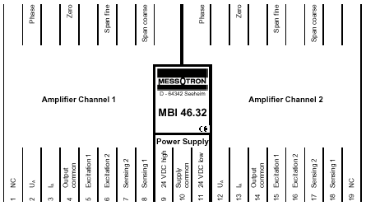
100 mm
125 mm
110 mm
75 mm
Figure 5 Enclosure dimensions

Placing into Service
NOTICE
NOTICE

Only qualified skilled persons are allowed to place the measuring amplifier into service.
NOTICE

Electrostatic discharge at electronic assemblies can damage the components before they are placed into service. Therefore, take all necessary measures to avoid electrostatic charging (ESD protective measures).

Provided the sensor cable is routed professionally, the distance between the displacement sensor and the measuring amplifier can be 100 m and more.

NOTE | Connect the inductive displacement sensor with the measuring amplifier using a screened, low-capacitance cable.
NOTE | Do not route the cable in parallel with power lines. In addition, maintain a sufficient distance to electric drives, transformers and frequency converters.

Pin assignment
NOTICE
NOTICE

The connections are not protected against reverse polarity.
If connections are reversed or if an incorrect external voltage is applied, the device can be destroyed.

The displacement sensors must be connected to the measuring amplifier according to the pin assignment specified in the table below. The power supply, the output signal and the displacement sensor are connected using terminals. Therefore, no soldering is required for installation.
BU – blue
RD – red
WH – white
BK – black
BN – brown
YE – yellow

The conductor color code corresponds to IEC 60757:

Terminal row | Connection | Assignment
1 | Amplifier channel 1 | NC (not used)
2 | Amplifier channel 1 | Voltage output U_{A}
3 | Amplifier channel 1 | Current output I_{A}
4 | Amplifier channel 1 | 0 V Output
5 | Amplifier channel 1 | Excitation voltage + (for displacement sensor)
6 | Amplifier channel 1 | Excitation voltage - (for displacement sensor)
7 | Amplifier channel 1 | Gain input - (measuring signal - from displacement sensor)
8 |  | Gain input + (measuring signal - from displacement sensor)
9 | Power supply | Supply voltage 24 VDC, high  or +15 VDC
10 | Power supply | 0 V (only with supply voltage +/- 15 VDC)
11 | Power supply | Supply voltage 24 VDC, low  or -15 VDC
12 | Amplifier channel 2 | Voltage output U_{A}
13 | Amplifier channel 2 | Current output I_{A}
14 | Amplifier channel 2 | 0 V Output
15 | Amplifier channel 2 | Excitation voltage + (for displacement sensor)
16 | Amplifier channel 2 | Excitation voltage - (for displacement sensor)
17 | Amplifier channel 2 | Gain input - (measuring signal - from displacement sensor)
18 | Amplifier channel 2 | Gain input + (measuring signal - from displacement sensor)
19 | Amplifier channel 2 | NC (not used)
Figure 6 Pin assignment of measuring amplifier
If the displacement sensor is connected according to the table above, there is a positive (increasing) output signal, when the core moves out of the displacement sensor or the measuring tube moves downward from the sensor housing. If a negative (decreasing) signal is desired for this direction of movement, switch the connections 5 and 6 (or 15 and 16).

Amplifier |  |  | Linear Variable Differential Transformers  all Dxx |  |  | Linear Variable Inductance Transducer  all Wxx except WP |  |  | Long-stroke sensor e.g. WP
Channel 1 | Channel 2 |  | Wire strand | Cable | Plug | Wire strand | Cable | Plug | Cable | Plug
5 | 15 |  | WH (BN) | WH | 2 (B) | BU | BU | 3 (C) | BU | C
6 | 16 |  | BU | BU | 3 (C) | RD | RD | 2 (B) | RD | B
7 | 17 |  | RD | RD | 1 (A) | - | - | - | - | -
8 | 18 |  | BK | BK | 4 (D) | WH+YE | WH | 1 (A) | WH | A
Figure 7 Connection of MESSOTRON displacement sensors

Setting options of the measuring amplifier
The measuring amplifier must be adapted to the displacement sensor used. With the 2-channel version, each channel must be adapted individually. The following parameters must be set:
- Position of the electrical zero point,
- Phase compensation (possibly caused by the sensor type and the connecting cable),
- Gain (compensation of sensor sensitivity).
At the factory, a basic configuration for all three parameters is set in the measuring amplifier. This is achieved by using a variable component assembly (resistors / capacitors) based on:
- a reference displacement sensor, if the sensor type is known,
- the sensor specification provided by the customer,
- the sensor that may have been ordered at MESSOTRON together with the amplifier or
- a typical adjustment, if the sensor is unknown.
The basic configuration can be changed, if required (see chapter 5.4 Basic configuration of measuring amplifier), for instance if a different sensor is used or if the output range of the measuring amplifier is changed (such as from 0 V...10 V to ±10 V).
In any case, the measuring amplifier must be adjusted to the sensor used on site using the trimming potentiometer (see chapter 5.3 Adjustment using trimming potentiometer). The measuring amplifier will be fine-tuned at the MESSOTRON factory, if a sensor is ordered together with the measuring amplifier.

Position of the electrical zero point
The electric output signal of a real inductive displacement sensor is not always exactly zero at the mechanical zeropoint (Dimension A for MESSOTRON displacement sensors). Material and manufacturing tolerances may cause small deviations, which can be compensated using the zero-point potentiometer. Small tolerances in mechanical adjustments of the displacement sensor can be compensated in the same way.
Figure 8 Correction of the zero point
If the zero-point potentiometer is twisted, this will result in a vertical shift of the characteristic curve for measured displacement to output signal.
If a more significant shift of the electrical zero point is required (e.g. to the start or to the end of the measuring range), the basic setting must be changed. This can only be accomplished by changing fixed resistors (refer to chapter 5.4.3).

Phase compensation
Due to the design principle, inductive displacement sensors can show a phase shift between the excitation voltage and the measurement voltage.
The measuring amplifier evaluates the ratio of excitation voltage and measuring voltage to suppress any measurement errors due to fluctuations of the excitation voltage. If the phase shift is not compensated, the sensitivity of the sensor can deviate.
Figure 9 Phase shift
Error: Reference source not found shows that there is a reduced voltage ratio of U_{M1}/U_{S} if there is no phase compensation. Phase compensation results in an optimized voltage ratio U_{M2}/U_{S}.
The phase compensation of the MBI 46.32 shifts the evaluation of the measurement voltage on the time axis in such a way that the phase position caused by the displacement sensor is compensated and the full sensitivity of the displacement sensor can be used.

Gain
To obtain the desired output signal, the gain of the measuring amplifier must be set depending on the rated output of the displacement sensor used. If the output signal does not reach the desired value, e.g. at the end of the nominal stroke, the gain must be increased.
Figure 10 Gain correction
A larger gain causes an increase in the gradient of the displacement-to-output-signal characteristic curve (or a counter-clockwise rotation of the characteristic curve).

Adjustment using trimming potentiometer
NOTE  NOTE | Make sure that the basic configuration of the measuring amplifier is suitable for the displacement sensor used. If this is not the case, change the basic configuration as described in chapter 5.4.

For the 2-channel version, note that each of the two integrated amplifiers must be adjusted. The two displacement sensors are then permanently assigned to the respective amplifier.

Using the trimming potentiometers, the measuring amplifier can be adjusted to the displacement sensor within certain limits. Likewise, small tolerances in adjustments of the displacement sensor can be compensated in the same way.
NOTE | The measuring amplifier will only show its nominal characteristics after a warm-up time of approximately 15 minutes.

Figure 11 Location of trimming potentiometers
With the option “/GP” (Coarse pot), do this to set the gain:
- Move the fine potentiometer P_{E} to the mid-position.
- Roughly set the gain using the coarse potentiometer P_{GP},
- Then use the fine potentiometer P_{E} for precise adjustment.

Adjustment for symmetric displacement sensors
With symmetric displacement sensors, the electrical zero is at the center of the nominal stroke. Typically, the voltage output of the measuring amplifier provides a symmetric output signal (-10 V...0 V...+10 V) for a symmetric displacement sensor. The current output provides a current of 12 mA (output ranges 4 mA...12 mA...20 mA) at the zero position.

NOTE | Other output ranges, e.g. 0...10 V, require a zero offset according to chapter 5.4.3.

- To adjust the zero point, remove the core from the sensor housing and set the output signal of the measuring amplifier to 0 V or 12 mA using the zero-point potentiometer P₀. Reinsert the core into the displacement sensor and secure the core to retain the output signal. Small corrections are permitted when using the zero-point potentiometer after the mechanical adjustment.
If you cannot set the zero point as described above, then alternatively bring the core into the position where the displacement sensor provides the same value with the usual connection as well as with switched excitation wires (terminal 5 and terminal 6).
- To adjust the phase, move the core to a position just before the end of the (nominal) measuring range. Then set the maximum of the output signal using the phase potentiometer P_{Ph}. If the output signal is no longer close to the desired value, adjust the gain, if necessary.
- To adjust the gain, move the core to the end of the (nominal) measuring range and use the gain potentiometer P_{E} to set the voltage to the desired value (usually 10 V or 20 mA). Then check the setting at the start of the nominal measuring range and correct slightly, if required.

Setting instruction for asymmetric displacement sensor (e.g. type WP)
The electrical zero of asymmetric displacement sensors is typically at the start of the nominal stroke. Usually measuring amplifiers for asymmetric displacement sensors are set to provide an output signal of 0...10 V (or 4...20 mA) in the (nominal) measuring range of the displacement sensor.
- To adjust the zero point, move the measuring tube of the displacement sensor into the mechanical zero position (dimension “A”) according to the data sheet. Then set the output signal of the measuring amplifier to 0 V or 4 mA using the zero-point potentiometer P₀.
- To adjust the phase, move the measuring tube to a position just before the end of the (nominal) measuring range. Then set the maximum of the output signal using the phase potentiometer P_{Ph}. Adjust the gain, if necessary. Then check and correct the zero-point adjustment, if necessary.
- To adjust the gain, move the measuring tube to the end of the (nominal) measuring range and use the gain potentiometer P_{E} to set the output signal to the desired value (usually 10 V or 20 mA).

Basic configuration of measuring amplifier
If the adjustment range of a trimming potentiometer is not sufficient for the required adjustment, you must change the basic configuration. To change the basic configuration, solder in fixed resistors and/or capacitors on the front board or the amplifier board.
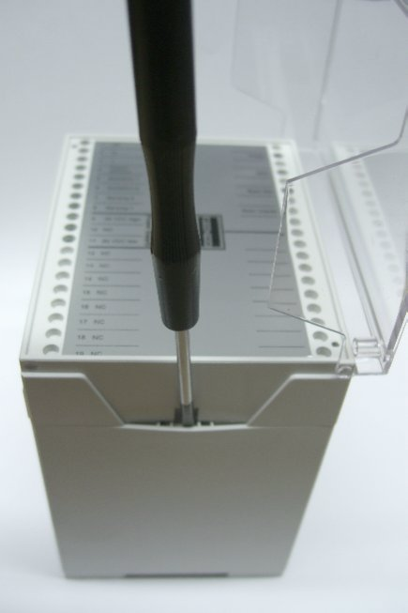 | To open the housing, press in the front panel at the sides and remove the front panel.
Figure 12 Opening the housing
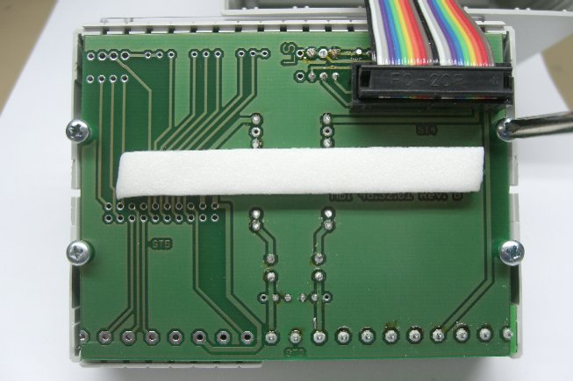 | You will find the front board on the backside of the front panel. Loosen the four screws on the rear to remove the front board.
Figure 13 Removing the front board

If you need to work on the amplifier board, carefully pull the amplifier board out of the enclosure. In the 2-channel version, there are two amplifier boards in the enclosure.

NOTE | If you cannot do the basic configuration on site, you can also have the conversion done at the factory. In this case, send the measuring amplifier freight prepaid along with your requirements (measuring range, desired output range) to MESSOTRON. If you are using a third-party sensor, we also need the displacement sensor or at least its specifications.

Location of fixed resistors and capacitors
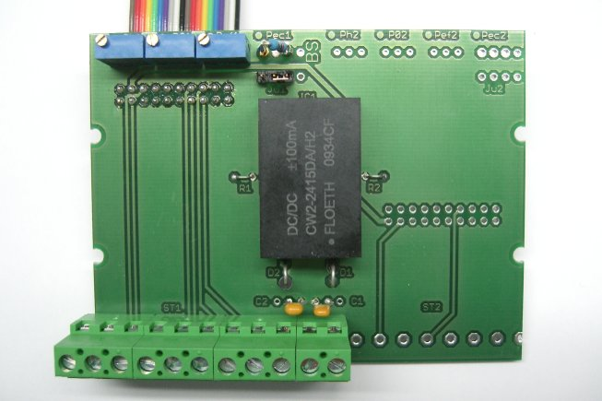
The location of the components that may have to be replaced is shown in the following figures:
Phase potentiometer P_{PH}
Zero-point potentiometer P₀
Gain potentiometer P_{E}
Resistor R_{E} for basic gain setting (Pot with option /GP)
Jumper JU1:
left (J₁): Preamplification on
right (J₂): Preamplification off (default setting)

Figure 14 Location of setting components on front board
The three (four) potentiometers are shown for better orientation. They are not intended to be replaced.
With the 2-channel version, the right-hand side of the front board is also equipped.
The elements of the second amplifier are identified by the index “2”.
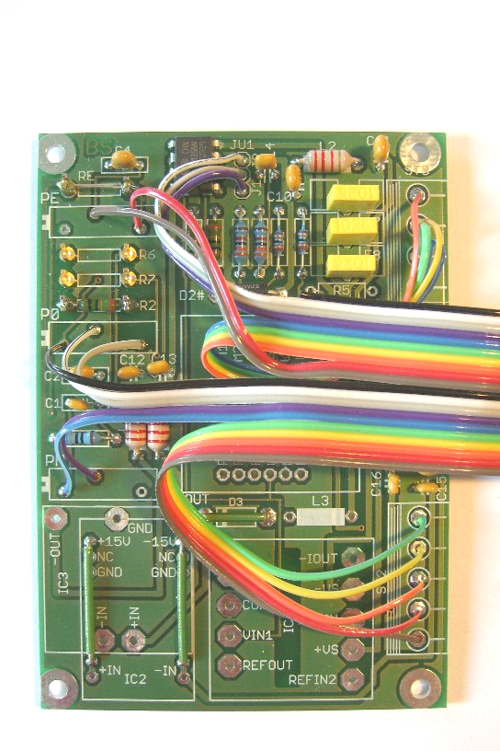

Figure 15 Location of capacitors C₁ and C₂ on the amplifier board

Figure 16 Location of resistors R₂, R₆ and R₇ on the amplifier board
NOTE | Only use resistors with a small temperature coefficient (TK25 or TK50).

Setting the phase compensation
The capacitors C₁ and C₂ are used together with the potentiometer P_{PH} to compensate for a phase shift between the excitation voltage and the measurement voltage. Capacitor C₁ compensates a positive phase shift. Capacitor C₂ compensates a negative phase shift. The potentiometer is used for adjustment.
- Position the immersion core or the measuring tube to approx. ¾ of the (positive) displacement.
- Instead of C₁ connect a capacitance decade box and determine the capacitance at which the output signal reaches its maximum.
- If the output signal decreases, then connect the decade box instead of C₂ and look for the maximum of the output signal there.
- For C₁ and/or C₂ solder in a capacitor which is approx. 10...20 % larger than the value you have determined.
- If both capacitors cause a reduction of the output signal, no phase capacitor is required.
- Then set the zero point and the gain.

Zero point / output range offset
If the adjustment range of the zero-point potentiometer P₀ is insufficient, it can be extended by reducing the resistor R₂.
NOTE  potentiometer  NOTE | For reasons of stability, do not choose a smaller resistance value for R₂ than necessary.

If only a positive (asymmetric) output voltage of e.g. 0... 10 V is required when using a symmetric displacement sensor, a larger offset of the output range is required. The offset resistors R₆ (negative offset of output signal) and R₇ (positive offset of output signal) are provided for this purpose.
- Do a phase compensation before offsetting the output signals with the offset resistors.
- Then adjust the gain of the measuring amplifier. The stroke of the output signal in the measuring range must correspond to the desired output range. In this example -5...+5 V = 10 V. To do so, it will usually be necessary to replace the resistor R_{E} (see 5.4.4).
- With resistor R₇, you are now able to offset the output range in the positive direction from -5...+5 V to 0...10 V.
- Similarly, you can also move the output range in the negative direction if, for example, a symmetrical voltage output is required for an asymmetric displacement sensor (offset with R₆).
- You can also move the zero point to the end of the measuring range (output signal is positive). In this case, you must switch the excitation wires terminal 5 and terminal 6 (and/or terminal 15 and terminal 16) and install the offset resistor R₆.

NOTE | The required resistance values for the offset depend, among other things, on the adjusted amplification of the measuring amplifier. It is advisable that you use a resistance decade box to dimension the resistors. Connect it to the soldering terminals of the resistance to be determined.

NOTICE
NOTICE

Determine the required resistance value R₆ or R₇ by reducing the decade value step by step – starting with 50 kΩ. When switching the decade box, make sure that the resistor is not short-circuited. Failure to do so can destroy the measuring amplifier.

- Then select a suitable fixed resistor R₆ or R₇ (±5 %) and solder it to the soldering terminals provided.
Figure 17 Different output ranges

Basic configuration of gain
The preamplifier, the fixed resistor R_{E} and the trimming potentiometer P_{E} determine the gain of the measuring amplifier.
The fixed resistor and the trimming potentiometer (default 50 kΩ) are connected in series. The fixed resistor R_{E} determines the minimum and maximum gain, as well as the adjustment range of the trimming potentiometer (adjustment).
With option /GP, a potentiometer P_{GP} for coarse adjustment is fitted instead of the fixed resistor R_{E}. The procedure for setting the gain described below applies in all cases, also with option /GP. A suitable resistor does not need to be determined and installed. Instead the required gain is set using the coarse potentiometer.
Displacement sensors with known rated output:

NOTE | First check the position of jumper JU1. It provides a 6x pre-amplification of the measurement voltage.  - If the rated output (determined independently of the phase) of the sensor is 60 mV/V or more then the preamplifier can be switched off (jumper JU1 in plug position J₂).  - If the rated output is less than 60 mV/V, it is advisable to activate the preamplifier (jumper JU1 in plug position J₁. This minimizes the temperature-related error.

Normally the output range of the measuring amplifier is set to 4...20 mA (current output) or 0...+10 V or ±10 V (voltage output) for the nominal stroke of the displacement sensor used.

Figure 18 Finding R_{E} depending on the rated output of the sensor used (for the standard output range of the measuring amplifier)
After having switched the preamplifier on or off, a suitable fixed resistor R_{E} must be soldered in. Find the required value for R_{E} in Figure 18 and solder a corresponding fixed resistor to the soldering terminals for R_{E}.
Displacement sensor with unknown rated output, changing the output range or reduced measuring range:
In these special cases, the fixed resistor R_{E} cannot be determined using Error: Reference source not found. It must be determined by experiment.
- First switch off the preamplifier (jumper JU1 in plug position J₂)
- Instead of R_{E}, connect a resistance decade box.
- Move the trimming potentiometer P_{E} to the mid-position.
- Set the displacement sensor to the end of the (used) measuring range. Use the resistance decade box to determine the value at which the measuring amplifier provides the desired output signal. If the value is larger than 300 kΩ, switch on the preamplification and redetermine R_{E}in order to minimize the temperature-related error.
- For R_{E}, select a suitable fixed resistor (5 %) and solder it to the soldering terminals for R_{E.}

Optimizing the linearity characteristic of the measuring chain
The procedure for basic settings and adjustments described in the previous chapters applies to a measuring chain with an “ideal displacement sensor” without linearity deviation.
Some real displacement sensors show a distinctive “one-sided” linearity deviation. In these cases, the linearity behavior of the measuring chain can be further optimized taking into account the respective measuring task.
Figure 19 shows the typical linearity characteristic of a symmetric displacement sensor, as determined following the setting of the measuring amplifier as per the steps described above. The maximal linearity error in the measuring range considered is 0,5 %. It is zero in the middle and at the end of the measuring range.
Figure 19 Typical error curve of a displacement sensor, zero-error setting at the zero point and at the end of the measuring range

Optimization with the smallest possible error in the zero point
If the measuring task mainly requires a minimum error at the zero point of the displacement sensor, then the maximum deviation needs to be reduced in the measuring range.
- To do so, reduce the gain in small steps. This causes a “rotation” of the linearity curve around the zero point. The zero-error setting at the end of the measuring range is given up.

Figure 20 Ideal zero point, max. linearity error reduced to 0.32 %

Minimal error over the entire measuring range
Some measuring tasks do not require a certain measuring point to show a higher accuracy than others. In these cases, you can reduce the maximum linearity error in the entire measuring range further by giving up the zero-error setting in the zero point.
- Offset the linearity curve by slightly adjusting the zero-point potentiometer, until the maximum positive and negative deviation are of equal in magnitude.

Figure 21 Smallest deviation (max. 0.22 %) over the entire measuring range

Other linearity optimizations
Figure 22 Zero-error setting at the beginning and the end of the measuring range
You can further optimize the system depending on the measuring task by similar methods to those described in chapter 5.5.1 and 5.5.2. For instance, curve 4 shows the linearity characteristic of the measuring chain if the measuring amplifier is set to minimum deviation at the beginning and the end of the measuring range.
NOTE | To set the measuring amplifier according to these instructions, the linearity curve of the displacement sensor must be determined. As an option for all MESSOTRON displacement sensors, you can receive test reports with the linearity curve (according to 5.5.1 Optimization with the smallest possible error in the zero point).

Improving the noise rejection
The MBI 46.32 CF measuring amplifier series is suitable for use in highly dynamic applications. As delivered, the (3 dB) dynamic bandwidth is 1/10 of the carrier frequency. If only slow processes are to be measured, the dynamic bandwidth may be reduced for a better noise rejection performance.
- By fitting capacitor C4, you can additionally filter the output signal.
- First start with some 10 nF and then increase the capacitance incrementally.
- Make sure that the output signal is not distorted with the fast processes in your application. Otherwise you must select a capacitance value for C4 of the next smaller size.

NOTE | The actual capacitance value required for setting a specific dynamic bandwidth depends on the carrier frequency and the associated standard filtering of the measuring amplifier. Use a capacitance decade box (approx. 10...1000 nF) to determine the correct capacitors.

Operation
The MBI 46.32 measuring amplifier is designed for unattended continuous duty.
To take the measuring amplifier out of service, it must be disconnected from its voltage supply.

Repairs
NOTICE
NOTICE

Never try to repair a defective measuring amplifier. Repair attempts of any kind will immediately render warranty and liability claims invalid.

MESSOTRON electronics are designed for use in a rough industrial environment. They are designed for years of trouble-free operation.
In case of any malfunction or damage, please contact us by phone or email:
Phone: +49 (0) 6257 82331
Email: info@messotron.de
If required, send the product (freight prepaid) to:
MESSOTRON Hennig GmbH & Co KG
Friedrich-Ebert-Str. 37
64342 Seeheim-Jugenheim, Germany
Please enclose a delivery note and a detailed description of the error with all return shipments.

Maintenance

Preventative maintenance
The MBI 46.32 measuring amplifier does not contain any serviceable parts.

Cleaning
NOTICE
NOTICE

Electrostatic discharge at electronic assemblies can damage the components before they are put into service. Therefore, take all necessary measures to avoid electrostatic charging (ESD protective measures).

When cleaning, note the following:
- To clean the enclosure and the front panel, only use a soft, slightly moist cloth.
- Remove dry dirt from PCBs carefully using a vacuum cleaner or a brush.
- If foreign liquids get inside the device, have it checked by MESSOTRON before putting it back into service.

Disposal
The device, any accessories and the packaging must be disposed of in accordance with the respective national regulations. Observe the national and local regulations regarding environmental protection and the reclamation of raw materials.

EU Declaration of Conformity


Technical Specifications
General information
Operating temperature | 0...60 °C
Storage temperature | -25...85°C
Electromagnetic compatibility | DIN EN 61326-1

Measuring amplifier
Linearity error | < 0,1 % FSO
Carrier frequency | 5 kHz ±5 % (sine);  optional 1...20 kHz
Excitation voltage (primary) | approx. 2 V_{rms} @ 5 kHz, sinusoidal  max. 12 mA_{rms}
Input resistance (secondary) | approx. 200 kΩ
Output signal | 4...20 mA, impedance < 500 Ω or.  ±10 VDC, ballast resistor > 10 kΩ
Noise level and residual carrier voltage | < 5 mV_{rms}
Temperature coefficient of  zero point | < 0,10 % / 10 K @ 100 mV/V  < 0,15 % / 10 K @ 20 mV/V
Temperature coefficient of gain | < 0,05 % / 10 K @ 100 mV/V  < 0,15 % / 10 K @ 20 mV/V
Dynamic bandwidth | 500 Hz (± 3 dB)  (max. 1/10 of carrier frequency)
Supply voltage | MBI 46.32.1y: ±15 VDC stabilized  MBI 46.32.3y: +20...+36 VDC  MBI 46.32.4y: +20...+36 VDC for  2-channel version
Power consumption | max. 2 W per channel
Electrical connection | 19-pin terminal block
Dimensions without see-through cover  Dimensions with see-through cover | approx. W 100 x H 75 x D 110 mm  approx. W 100 x H 75 x D 125 mm
Weight | approx. 0.35 kg (1-channel version)  approx. 0,45 kg (2 channel version)

Suitable sensors
Inductive differential  transformers (LVDTs) | with 4-wire technology
Differential inductor (LVITs) and long-stroke sensor (eddy current design) | Inductive half bridges with 3-wire technology
Rated output | 20...600 mV/V
Input impedance | 100...1000 Ω

Subject to alterations. Errors and omissions excepted.

© 2018 MESSOTRON Hennig GmbH & Co KG

MESSOTRON Hennig GmbH & Co KG
Friedrich-Ebert-Str. 37
64342 Seeheim-Jugenheim, Germany

Phone: 06257 82331
Fax: 06257 85783
Email: info@messotron.de
Homepage: www.messotron.com

